**Hazard Analysis and critical control points (HACCP) - Manufacturing Sector**

GOKULNATH K & E24755

**Overview**

Hazard Analysis and Critical Control Points (HACCP) in the manufacturing sector is a preventive approach focusing on identifying and mitigating potential hazards in production, especially for food safety. A data analyst’s role involves gathering and analyzing process data to monitor critical control points (CCPs), assess risks, and ensure compliance with safety standards. They provide insights through data visualization, enabling real-time monitoring and decision-making. Predictive analytics can be used to forecast potential hazards and trigger timely corrective actions.

**Objective**

1. **Hazard Identification**: Use data analysis to identify potential biological, chemical, and physical hazards in the manufacturing process.
2. **Critical Control Points (CCPs) Monitoring**: Develop systems to track and monitor critical control points (like temperature, time, or contamination risks) to ensure safety thresholds are met.
3. **Data-Driven Risk Assessment**: Perform quantitative risk analysis using historical data to assess and predict the likelihood and impact of hazards.
4. **Real-Time Analytics**: Implement real-time data monitoring for continuous surveillance of production processes to detect deviations early.
5. **Optimization of Control Measures**: Use data insights to improve the efficiency of control measures and enhance product safety protocols.
6. **Regulatory Compliance**: Ensure that data analytics supports meeting safety and quality standards set by regulatory bodies.
7. **Predictive Maintenance**: Apply predictive analytics to forecast equipment failures that may introduce hazards into the process.
8. **Reporting and Visualization**: Provide clear reports and visualizations to support decision-making and timely corrective actions.

**Assigned Task(s)**

* Hazard Analysis and critical control points (HACCP) - Manufacturing Sector.

**Task Details**

* **Task 39 :** Hazard Analysis and Critical Control Points (HACCP) in the manufacturing sector involves using data analytics to monitor and control potential hazards, ensuring product safety. A data analyst focuses on tracking critical control points (CCPs), risk assessment, and optimizing safety measures through data insights.
* **Status:** Completed.
* **Details:**

1. Defined Critical Control Points (CCPs): Thresholds set for temperature (75°F), contamination level (5 units), and production time (8 hours).
2. Marked Exceeded CCPs: Flagged entries where temperature, contamination, or production time exceeded defined thresholds.
3. Summarized CCP Violations: Generated a summary showing the count of exceeded CCPs for temperature, contamination, and time.
4. Temperature vs. Contamination Visualization: Plotted temperature against contamination, highlighting exceeded temperature levels and contamination thresholds.
5. Production Time vs. Temperature Visualization: Created a scatter plot to visualize the relationship between production time and temperature, with thresholds marked.
6. Contamination vs. Defect Rate Visualization: Analyzed contamination levels and their impact on defect rates with a scatterplot.
7. Temperature Distribution: Created a histogram of temperature with count labels on top of each bar.
8. Maintenance Frequency vs. Defect Rate: Generated a boxplot to explore the relationship between maintenance frequency and defect rates.
9. Downtime by Equipment ID: Visualized the distribution of downtime for each equipment using a boxplot.
10. Batch Size vs. Temperature: Created a scatterplot to analyze how batch size affects temperature.

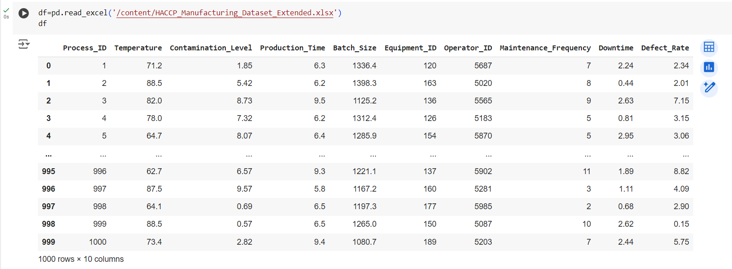

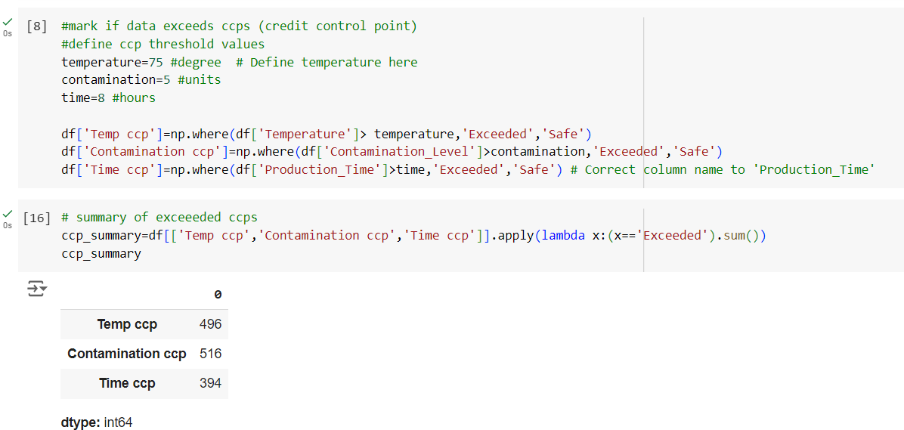

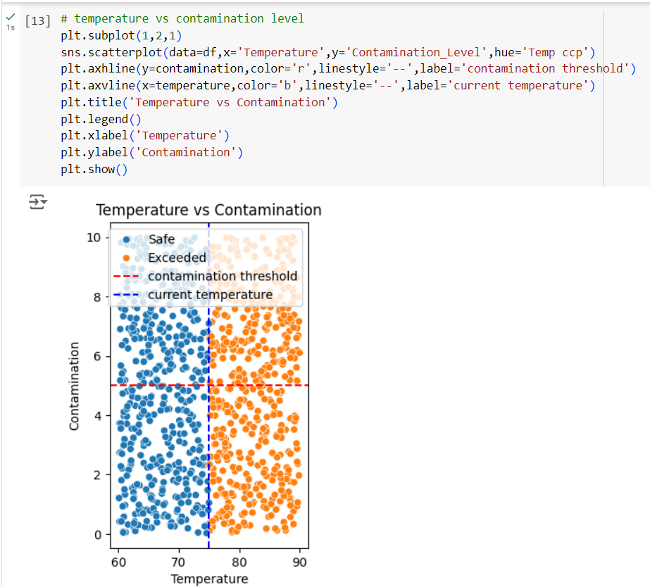

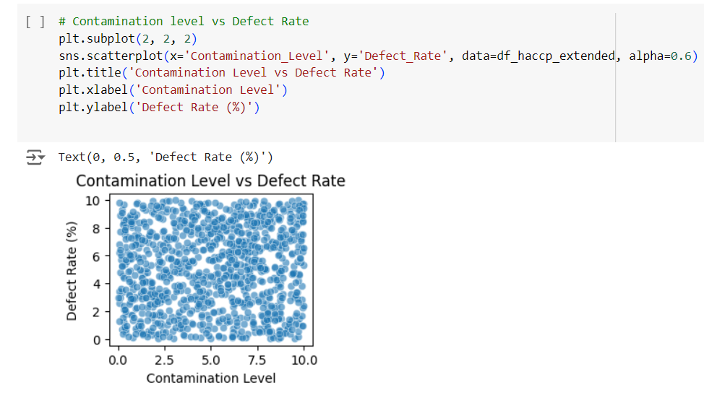

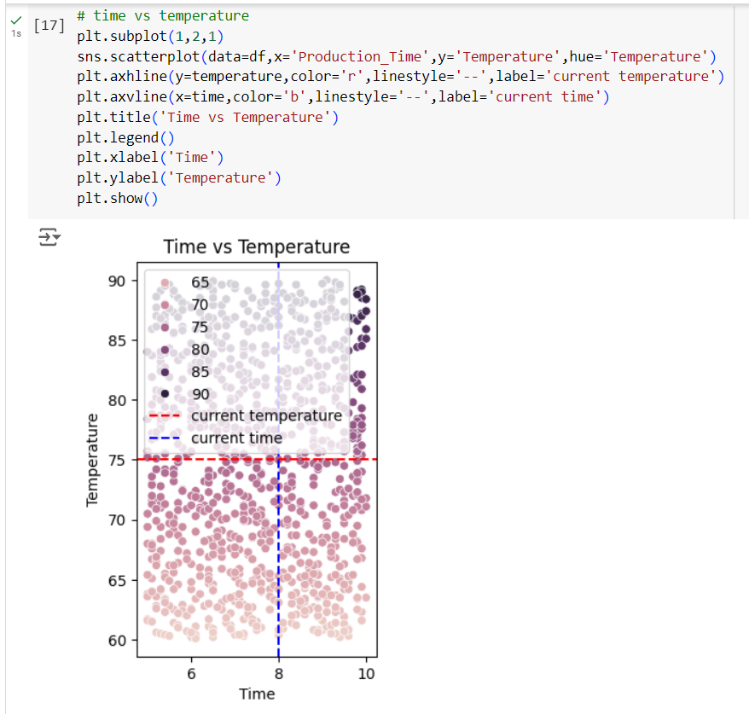

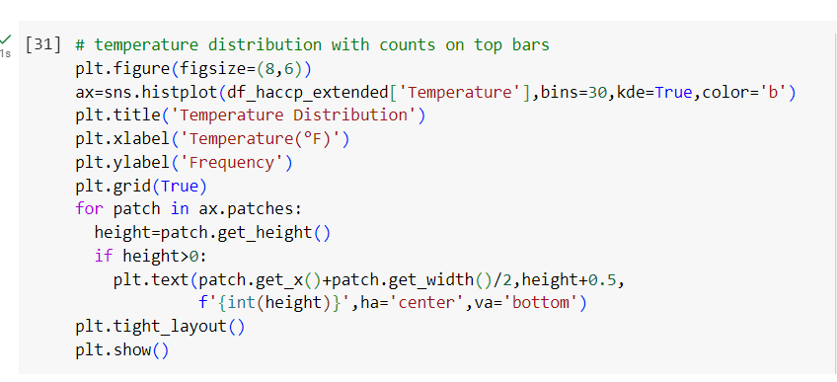

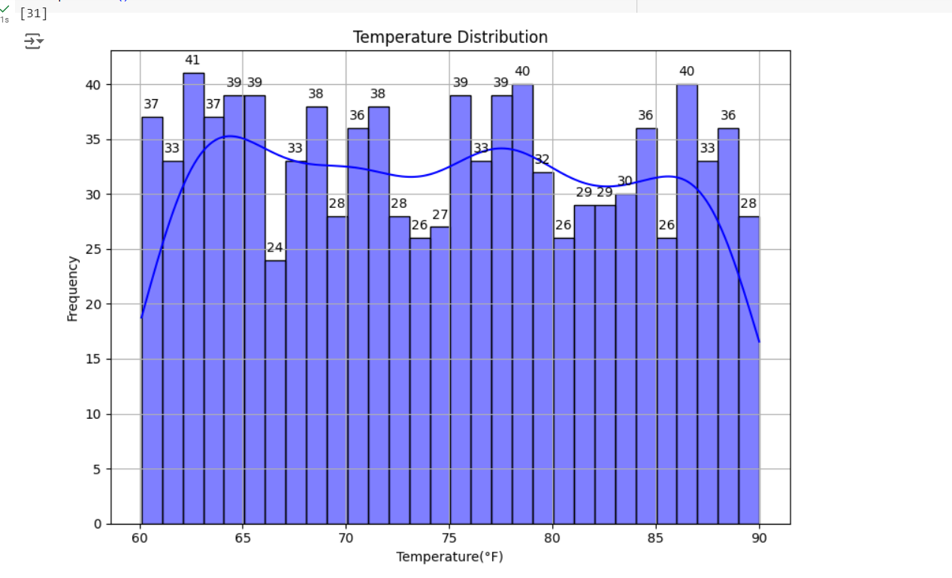

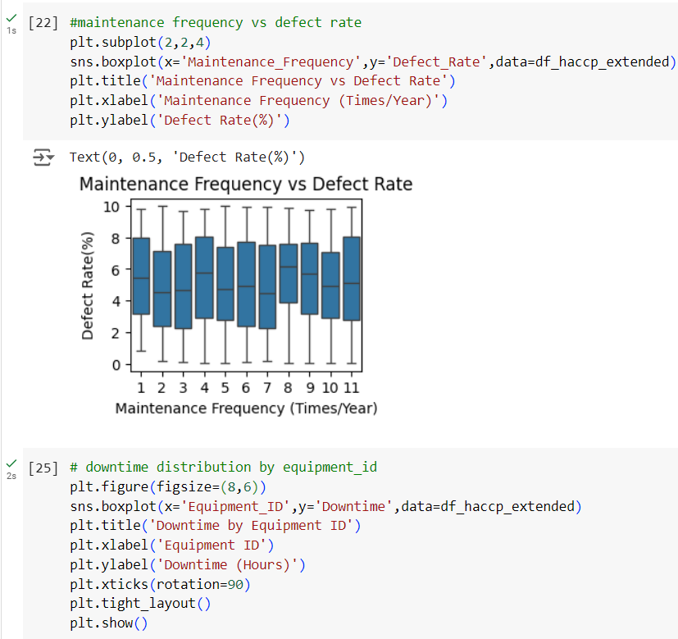

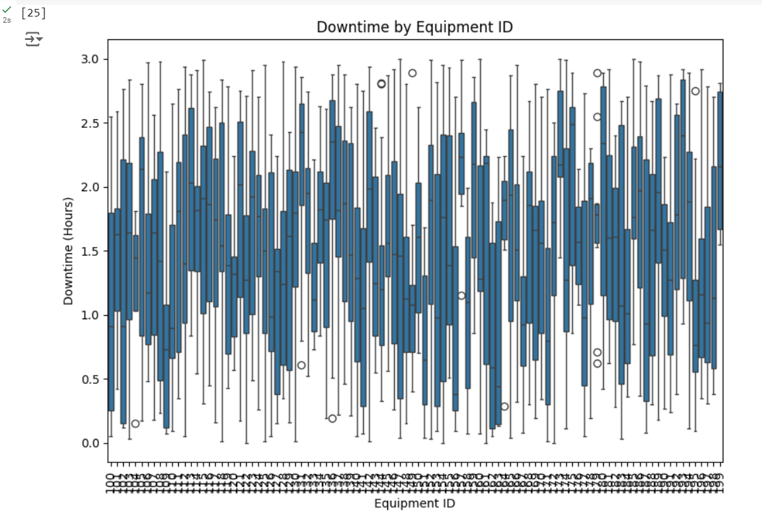

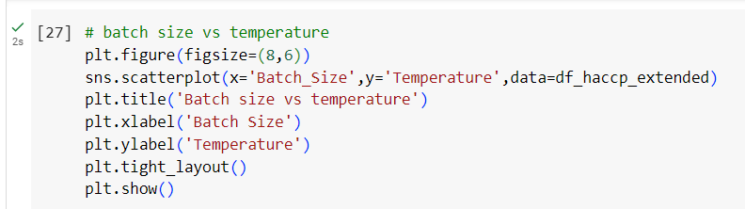

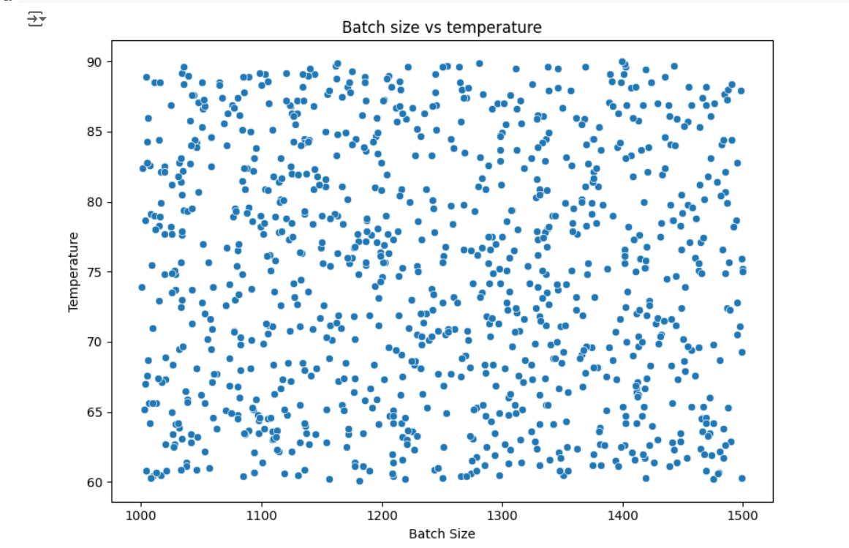

**Progress**

* **Accomplishments:**

1. Defined and monitored critical control points (CCPs) for temperature, contamination level, and production time.
2. Flagged and summarized instances where CCPs were exceeded for quick analysis.
3. Visualized critical relationships, including temperature vs. contamination and production time vs. temperature, for process optimization.
4. Analyzed defect rate trends against contamination levels and maintenance frequency for quality improvement.
5. Explored downtime patterns by equipment ID and batch size impacts on temperature for operational efficiency.

* **Metrics:**

1. Temperature Threshold: 75°F (CCP exceedance).
2. Contamination Level Threshold: 5 units (CCP exceedance).
3. Production Time Threshold: 8 hours (CCP exceedance).
4. Exceeded CCP Count: Total instances of exceeded temperature, contamination, and production time.
5. Defect Rate: Percentage of defective products based on contamination levels and maintenance frequency.

**Challenges and Solutions**

* **Challenges Faced:**

1. The multifaceted nature of manufacturing processes complicates data analysis and interpretation.
2. Difficulty in implementing real-time data monitoring and analysis due to equipment and integration limitations.
3. Ensuring compliance with stringent regulations and standards can be challenging without adequate data management.

* **Solutions Implemented:**

1. Utilize process mapping to simplify complex processes and improve data collection methods.
2. Invest in automated monitoring systems for real-time data collection and analysis.
3. Develop comprehensive checklists and dashboards to track compliance with regulations.

**Next Steps**

* **Upcoming Tasks:** To face upcoming tasks in the manufacturing sector, focus on improving data accuracy, optimizing processes, embracing automation, ensuring compliance, and enhancing team skills through training.
* **Goals:** To achieve upcoming goals, set clear objectives, prioritize tasks, leverage data-driven insights, and foster collaboration among team members.

**Conclusion**

* **Summary:** In the manufacturing sector, effective implementation of Hazard Analysis and Critical Control Points (HACCP) is crucial for ensuring product safety and compliance with regulations. By focusing on data quality, real-time monitoring, and staff training, organizations can identify and mitigate potential hazards. Continuous improvement and adaptation to regulatory changes are essential for maintaining operational efficiency. Ultimately, a robust HACCP framework enhances product quality and safeguards public health.
* **Acknowledgements:** Thank you all for your attention and engagement, I appreciate your interest in the Hazard Analysis and critical control points (HACCP) - Manufacturing Sector.